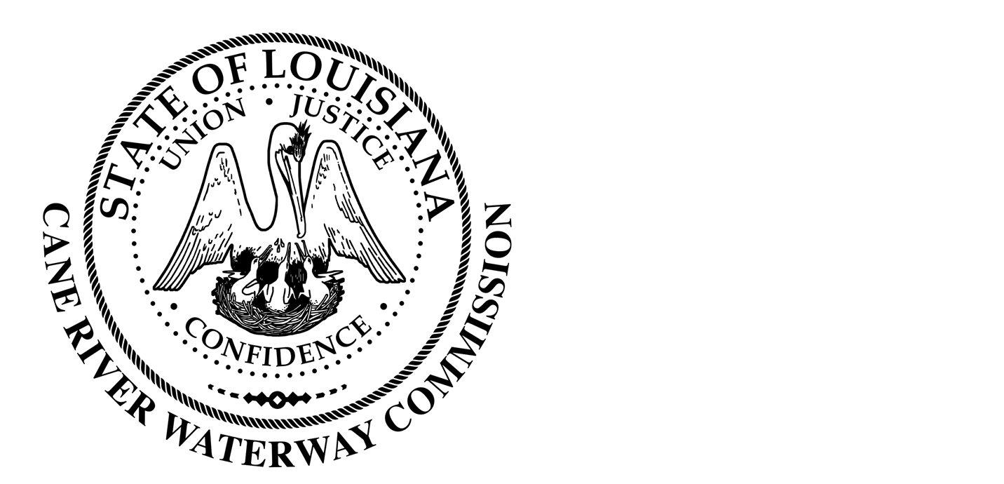
Cane River Waterway Commission
Minutes
April 18, 2023

There was a public hearing of the Cane River Waterway Commission on April 18, 2023, at 6:00 pm located at 244 Cedar Bend, Natchez, Louisiana.
The hearing was called to order and roll was called with the following members being present: Mr. Rhodes, Mr. Methvin, Mrs. Banks, Mr. Methvin, Mr. Wiggins and Mr. Paige
Also present was Director of Operations Jason Adcock and Attorney Tommy Murchison.
Mr. Benny Dobson with the Soil and Water Conservation District presented the board with their 23-24 plan for feral hog control. Mr. Dobson advised that last years plan was able to remove approximately 840 hogs just in the Cane River Water shed. Mr. Paige motioned to match the 22-23 contribution of $25,000 to the Soil and Water District for the feral hog control. Seconded by Mr. Methvin and unanimous vote by Mr. Rhodes, Mr. Wiggins, Mrs. Banks, Mr. Paige and Mr. Methvin the Commission approved $25,000 to be contributed to the Soil and Waterway District.
The minutes of the regular meeting on February 15, 2023, were presented. The Chairman opened the floor to public comments and after discussion the Chairman closed the floor to discussion. Upon motion by Mr. Wiggins seconded by Mrs. Banks and unanimous vote by Mrs. Banks, Mr. Rhodes, Mr. Methvin and Mr. Wiggins the Commission approved the minutes of the February, 2023, meeting as written.
Mr. Adcock presented the board with the financial report for February 15-April 15, 2023. After motion made by Mr. Methvin seconded by Mr. Wiggins and unanimous vote by Mr. Rhodes, Mr. Paige, Mrs. Banks, Mr. Wiggins and Mr. Methvin the Commission approved the financial reports.
There being no further business to come before the Board, upon motion by Mrs. Banks seconded by Mr. Wiggins and unanimous vote by Mr. Wiggins, Mrs. Banks, Mr. Methvin and Mr. Rhodes, the meeting was adjourned.

________________________________
Approved by
__________________
Date

